MoMs for Business Operation Study Group - CRA

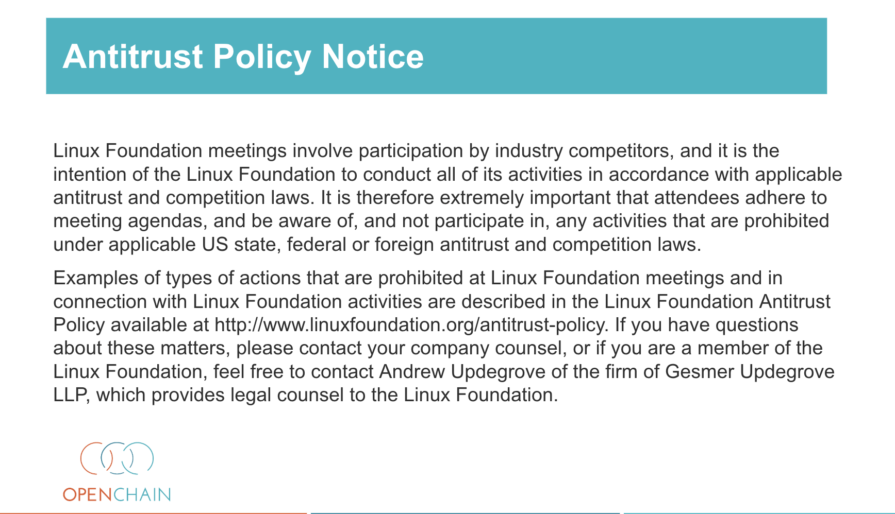

GOAL of this Study Group:

The study group aims to identify and normalise best practices for operational compliance up and down the supply chain in response to the new regulations (CRA), and to produce a practical checklist that sets out what good looks like, for building trust in the supply chain.

Date: Jun 29, 2026
CRA Workgroup needs to be formed soon. Due to time constraints.
CRA workgroup repo needs to be created in Github as an infor container.
Menu ‘CRA/CRA checklist’ needs to be created in OpenChain website.
Open for chairman position of CRA workgroup.

Date: Jul 27, 2026

Two Meeting dates set up:
- Open Chain Business Operations Study Group EU/ASIA on Monday 11:00 UTC (bi-weekly)
- Open Chain Business Operations Study Group NA/EU on Tuesday 14:00 UTC

Topic Backlog:
A Repository will be set up on https://github.com/OpenChain-Project by Mary for the topic backlog.

The goal of the backlog is gathering topics from the community seen as important for Operational Compliance. Topics can be selected to be individually addressed or help define a larger scope of Operational Compliance best-practice.

CRA checklist
The checklist is available for review and comments on Github and Google Documents.
- https://github.com/OpenChain-Project/CRA-Compliance/
- https://docs.google.com/document/d/1Wog28BZ9NQhY3tN9Wc2NDml2phBDuvYu9zkXSON5z5o/

CRA checklist related discussion:
- Identifying links of CRA requirements to existing standards (e.g. ISO 5230, 18974) to simplify gap analysis for CRA compliance, if other standards are already fulfilled.
- Source link documentation for the checklist requirement to in-text CRA sources.

